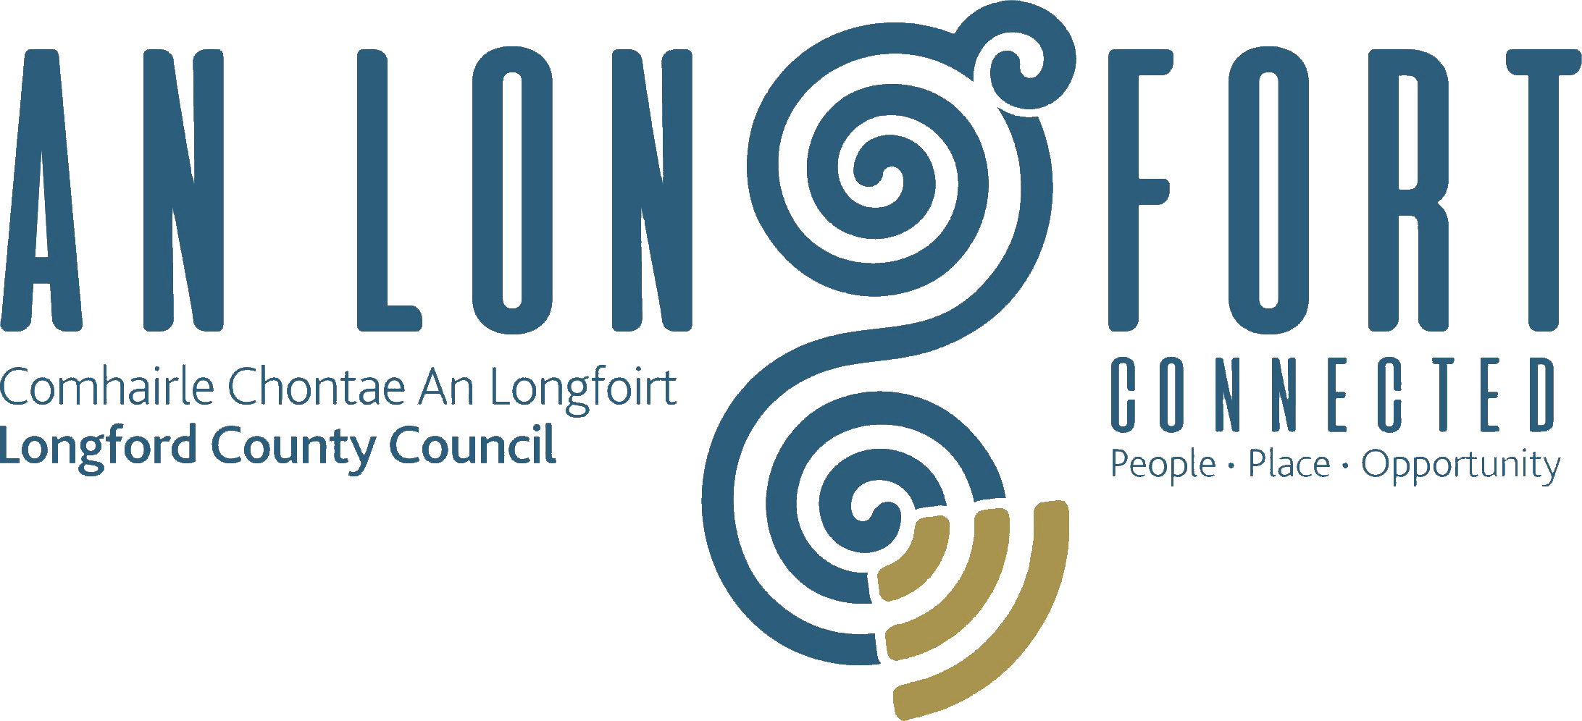

BALLYMAHON MUNICIPAL DISTRICT

Minutes of Meeting of Ballymahon Municipal District held,
using Microsoft Teams, on Tuesday, 7th April 2020 at 3.30 p.m.

__________________________________________________________________________

CATHAOIRLEACH: Councillor Pat O’Toole.

MEMBERS PRESENT: Councillors – Mick Cahill, Mark Casey, Gerard Farrell,
Colm Murray and Paul Ross.

IN ATTENDANCE: Mr. Paddy Mahon, Chief Executive.
Ms. Barbara Heslin, Director of Services.
Ms. Linda Higgins, Administrative Officer.
Mr. Paul Newell, Senior Executive Engineer.

MEETINGS
ADMINISTRATOR: Ms. Anne. Lee.

SUSPENSION OF STANDING ORDERS - MICROSOFT TEAMS.

The Cathaoirleach, Councillor Pat O’Toole, informed the members that due to the
COVID-19 Pandemic, this Municipal District meeting is being held using Microsoft Teams.
This was agreed to by the Members of Ballymahon Municipal District.

ADOPTION OF MINUTES.

On the proposal of Councillor C. Murray seconded by Councillor M. Cahill, the Minutes of Meetings of Ballymahon Municipal District held on the 23rd January and 14th February 2020, as circulated, were confirmed and adopted.

MATTERS ARISING FROM MINUTES.

None.

DECLARATION OF INTEREST BY MEMBERS.

Noted.

2020 COMMUNITY GRANT SUPPORT SCHEME – List circulated.

Barbara Heslin briefed the members on the applications received under the 2020 Community Grant Support Scheme and informed the members that €93,000 was available for distribution under the 2020 Community Grant Support Scheme. €13,000 of Special Projects funding has already being committed by the members.

Town Twinning €5,000
Voluntary Bodies Grants €18,667
Voluntary Bodies Grants Intercultural €3,333
Arts Activities €7,000
Tidy Towns Grants €23,000
Special Projects Grants €23,000 €13k already committed

Barbara stated that –

- There was a reduction in the number of applications received. Barbara suggested retaining some funding for later in the year
- Some new groups applied to the MD for the first time
- Some groups submitted multiple applications for different projects

Terms of the scheme
- The Corporate Policy Group agreed previously to set a limit of €2,000 on grant funding allocations with provision for one exceptional event each year which may exceed this limit.
It was agreed by the members that a number of groups be approved for once off funding for large scale projects.
- Funding will only be paid in to the bank account of the specific group which has been allocated funding by the MD - it is not permissible to pay grants in to a third party's bank account
- Groups must be affiliated to the PPN in order to qualify for support - the Elected Members may approve funding for groups subject to their registration with the PPN
- Each MD can agree specific conditions over and above the standard T&Cs. These are recorded on the spreadsheet and will be confirmed in the letter of offer

On the proposal of Councillor C. Murray seconded by Councillor M. Casey, it was agreed that due to the COVID-19 crisis, that all groups be requested to give an update to the Municipal District before the end of August confirming if their projects/events are going ahead in 2020.

Applications received under the Community Grant Support Scheme 2019 were considered,
in detail and agreed by the members - as per attached appendix.

Special Projects Fund - 2020 Approved Budget - €36,000.

It was noted that it was agreed at MD meeting held on the 23rd January 2020 that the
following amounts be allocated from the Special Projects Fund -
- €10,000 allocated to walk and cycle way project in Edgeworthstown
- €3,000 allocated towards the provision of a commemorative stone in Cloncallow Cemetery from the Special Projects Fund.

At today’s meeting it was agreed, on a once off basis, to allocate €10,000 to Abbeyshrule Tidy Village Association.

It was agreed that the remaining Special Projects Funding (13k) be considered at the next
MD Meeting.

2019 COMMUNITY GRANT SUPPORT SCHEME

Change of Use of Funding.

Ardagh Mountain Development Association.

On the proposal of Councillor M. Casey seconded by Councillor M. Cahill, it was agreed that the funding allocated under the 2019 Community Grant Support Scheme be used to install a pump and landscaping.

2019 - New Application

Bridgeways Family Resource Centre.

On the proposal of Councillor P. O’Toole seconded by Councillor M. Cahill, it was agreed that funding of €450.00 be allocated towards the 2019 Santa visit.

Conclusion.

Mr. Paddy Mahon, Chief Executive, addressed the members.

Paddy referred to the COVID-19 Pandemic and the measures being taken by Longford County Council to assist all communities in County Longford.

He referred specifically to The Community Call initiative which is a dedicated community support helpline established to assist at-risk older or vulnerable people who are recommended to cocoon and remain in their homes during this current period of the public health emergency. Assistance will be provided in accessing essential non-emergency and non-medical supports and advice during the emergency. The confidential phoneline service, which was established by the new COVID-19 Longford Community Response Forum, focuses primarily on ensuring that vulnerable members of the community or those living alone can access deliveries of groceries, medicine and fuels. The helpline has been operational since the 30th March 2020.

Paddy complimented the members of the Municipal District for embracing the use of Microsoft Teams to continue with the business of the Municipal District.

Councillor Pat O’Toole, Cathaoirleach, thanked the Chief Executive and staff for their work during this difficult time and also thanked Danny Lynch, Christine Collins and the
IT staff for their assistance in setting up Microsoft Teams for the members.

The Chief Executive, Cathaoirleach and members congratulated Councillor Michael Carrigy on his election to Seanad Éireann and commiserated with Councillor Mick Cahill who was unsuccessful on this occasion.

This concluded the business of the meeting.

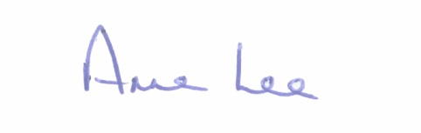

Signed: __________
Anne Lee,
Meetings Administrator.

Confirmed and adopted at Ballymahon Municipal District Meeting held on the
14th May 2020.

Signed: _______________
Cathaoirleach.

